**Learning activity 2 / A*ctividad de aprendizaje 2***

**Evidence: A world of differences and similarities / *Evidencia: Un mundo de diferencias y semejanzas***

Read the following paragraph about Scott Dinsmore’s morning routine. Scott is a 32-year-old entrepreneur, writer, and ultra-runner. Find similarities and differences between his routine and your routine. Write at least six sentences using the grammar and vocabulary you have learned in this learning activity. / *Lea el siguiente párrafo sobre la rutina de la mañana de Scott Dinsmore. Scott es un empresario, escritor y ultra-corredor de 32 años de edad. Encuentre similitudes y diferencias entre su rutina y la rutina de Scott. Escribe al menos seis frases utilizando la gramática y el vocabulario aprendido en esta actividad de aprendizaje.*

Example: / *Ejemplo:*

1. Scott and I usually get up at 6.00 am. / *Scott y yo por lo general nos levantamos a las 6:00 a. m.*
2. Scott exercises in the morning. I don’t like to exercise. / *Scott hace ejercicio en la mañana. A mí no me gusta hacer ejercicio.*

**Scott Dinsmore’s morning routine**

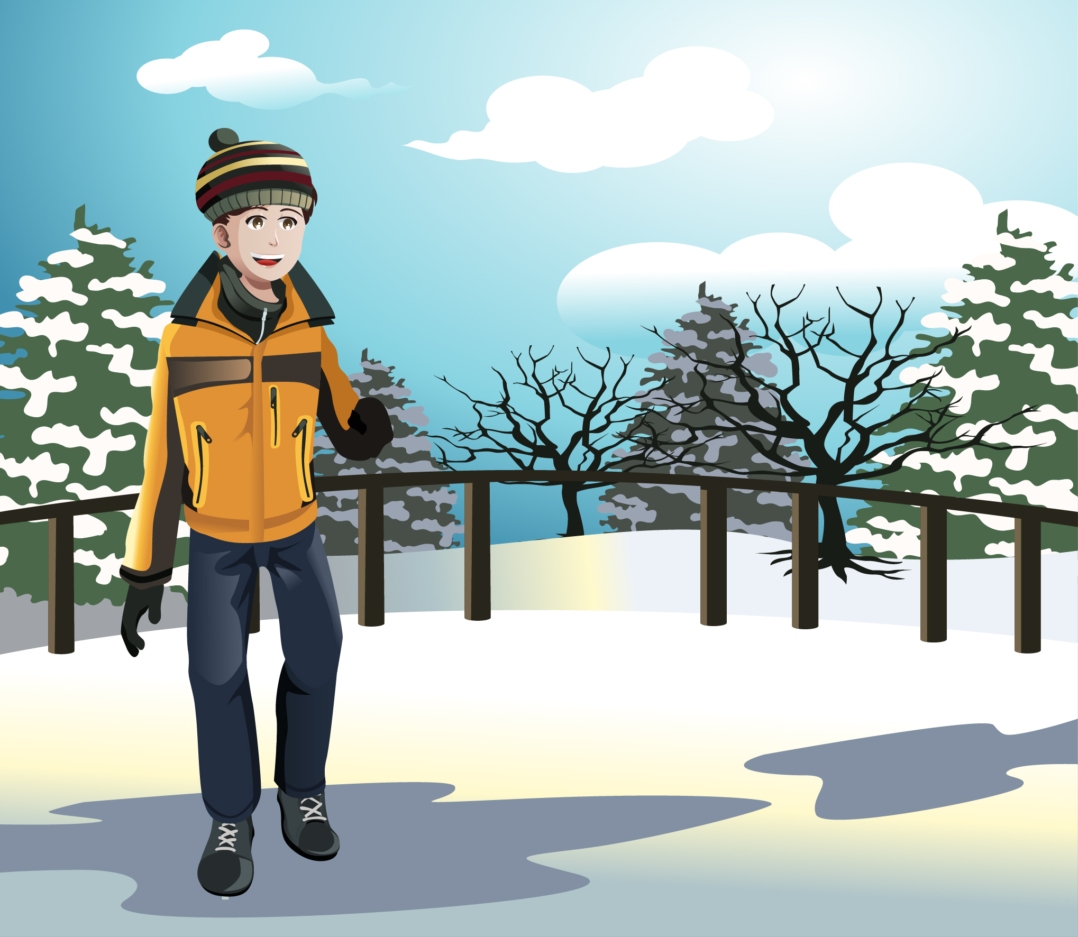

**Fuente:** SENA

Scott usually wakes up at 6.00 am. He always drinks a liter of water after he gets up. He says it is very important to be hydrated. He meditates from 6.10 to 6.30 am. He feels meditation is an essential element to avoid stress. He watches a TED talk or reads a little from 6.30 to 7.00 am. These activities give him inspiration to start the day. He exercises from 7.00 to 8.00 am. He says exercising clarifies his ideas. Then, he takes a cold shower at 8.10 am. He thinks cold showers increase testosterone levels and improve circulation. He has breakfast at 8.40 am. He usually has vegetable juice, bananas, peanut butter, and almonds. Finally, he does all his creative work from 8.40 to 12.00 m.

|  |
| --- |
| Similarities and differences |
| 1. Scott usually wakes up at 6 am I wake up at 7 am. |
| 2. Scott and I drink a liter of water. |
| 3.Scott meditates from 6:10 to 6:30 am but I don’t like to meditate. |
| 4.Scott and I exercise from 7 to 8 am. |
| 5.He takes a cold shower at 8:10 am. I don’t like cold shower |
| 6.Scott works from 8:40 to 12 m. I work from 8am to 6 pm. |

When you finish your work, send the file to your instructor through the platform as follows:

1. Click on “Ver Evidencia” button.
2. Attach the file which must be previously saved on the computer.
3. Leave a comment for the instructor (optional).

*Una vez finalice la evidencia envíe al instructor el archivo a través de la plataforma, así:*

1. *Clic en el botón "Ver Evidencia".*
2. *Adjuntar el archivo el cual debe estar previamente guardado en el equipo.*
3. *Dejar un comentario al instructor (opcional).*

**Note:** This evidence is an individual activity. Remember to check the learning guide in order to know if you have done all the assigned activities, know how to develop them and deliver them correctly.

***Nota:*** *esta evidencia es de carácter individual. Recuerde revisar la guía de aprendizaje con el fin de verificar que ha realizado todas las actividades propuestas, saber cómo desarrollarlas y entregarlas correctamente.*

|  |
| --- |
| ***Criterios de evaluación*** |
| * *Intercambia información respecto a rutinas, usando la estructura y vocabulario requeridos en un contexto.* * *Aplica la hora empleando la estructura y vocabulario requeridos en un contexto.* |